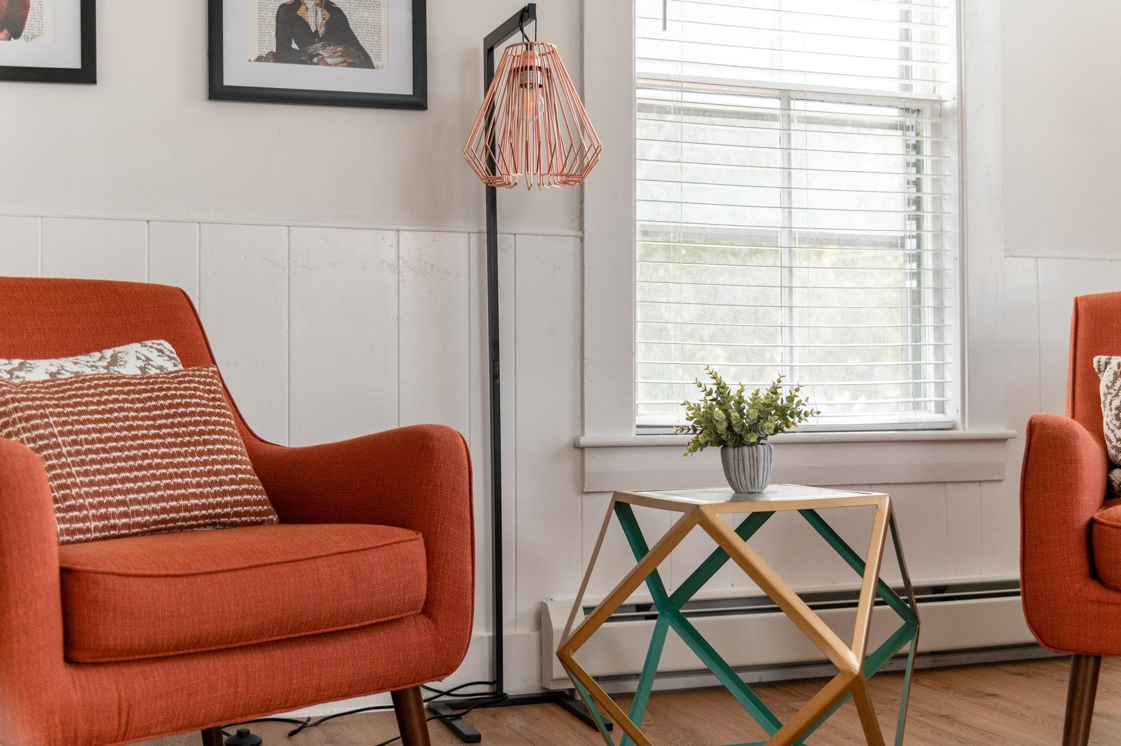
Image via Pexels

So you want to convert your primarily home into an investment property?

Are you on a mission to build wealth? Are you looking to kickstart your investment portfolio? Or, are you moving and just not ready to let go of your property just yet?

Converting your primary residence into an investment property is an excellent solution for each of these scenarios. But before diving into the process, it’s critical to set yourself up for success. Below, Kimberly Dixon-Dudley shares some practical tips!

Consider the Pros and Cons

Your first step will be to sift through the pros and cons of turning your home into a rental property. For example, it is a great way to diversify or supplement your income and build wealth, and you could use the rental income toward paying off your mortgage and maintaining a healthy cash flow. Renting out your home is also a good idea if you have been trying to sell it for a while with no offers because it could help you to break even.

Understand that if you choose to manage your investment property yourself, you will need to commit a lot of time and energy to the process and pay various expenses, such as maintenance, landlord’s insurance, attorney fees, and more. You will also need to consider that a fluctuating market could leave you with less income than you anticipate, and you must be aware of potential vandalism, theft, and other property crimes that could happen if you leave the property vacant for long periods.

Many younger adults are purchasing duplex properties to live on one side and convert the other side into an investment opportunity. This could also be an excellent method of building wealth and kickstarting your portfolio, whether you choose to lease to long-term tenants or use it as a vacation rental.

Spruce Up the Interior

You will likely need to perform some repairs and upgrades to your property before renting it out. First, make sure all the plumbing, electricity, appliances, and HVAC systems are in working order. You should also have the roof and other structural components of the home inspected in order to rule out any major repairs.

Furthermore, research the housing market to get an idea of what renters are looking for regarding interior features. The goal is to attract good tenants and to make any upgrades that will help you achieve that. Here are a few projects to consider:

- Replace worn-out carpets or hardwood floors.
- Install modern light fixtures with LED bulbs.
- Put a fresh coat of neutral paint on the walls and trim.
- Update the faucets, shower hardware, and cabinet hardware.
- Remove any popcorn ceilings.

Tend to the Exterior

Curb appeal is also critical when it comes to attracting tenants. Don’t worry about a complete home transformation; if necessary, take small steps gradually to improve the look of your home’s exterior.

For instance, you might invest in landscaping services to beautify the property as well as professional painting services if the siding needs some TLC. Furthermore, consider any DIY projects you could take on, such as painting the deck, repainting the mailbox and house numbers, or repairing broken steps.

If you choose to hire a landscaping service to boost your yard’s appeal, be sure to research and evaluate various companies in your area. You can quickly find customer reviews for local landscapers, and some of them might be offering credits or discounts on current landscaping projects.

Become a Marketer

When you decide to enlist your investment property, you will need to put on your marketing hat (even if you’ve never worn one before). It’s hard to go wrong with the proven strategy of creating a brochure to pass around town and leave at local businesses.

While you could invest in professional services, you could also use online brochure design templates to make your own. Many templates allow you to customize the images, text, and other design elements.

If you have decided to convert your primary residence into an investment property, it’s essential to approach it with a plan and strategy. The information and advice above will help you get off to a strong start. But keep looking for other ways to set yourself up to build wealth and diversify your portfolio!

Are you looking to buy or sell a property in the Houston area? Contact Kimberly Dixon-Dudley today! (713) 357-1616

